# CE318: High Level Games Development Assignment

# Ben MacIver (2104199)

# Title: Detonate Dash

**Overview**

The main premise of my game, Detonate Dash (working title) is a combination of a 3d platformer and first person shooter. The aim is to combine the high octane, adrenaline fuelled and hectic gameplay of a fast paced fps like Doom or Halo and put it in a 3d platforming environment. The players aim is to traverse from platform to platform and pass puzzles whilst also being swarmed by enemies and tests of fps accuracy in places you wouldn’t typically expect from a 3d platformer, in order to ensure the player is always on there toes in a simultaneously unique and familiar gameplay experience.

**Gameplay**

The main game state will be one where the player controlled from a first person perspective will be wielding two dual wield guns. Currently this is a high power handgun in the left hand and more precise and rapid fire rifle in the other. They will traverse through the level with a rather high movement speed jumping from platform to platform and past various puzzles whilst engaging with the environment with this movement system and their guns as a primary form of interaction (eg: shooting down obstacles. Once the player makes it to the end of this level then they win but if they fail one of their many obstacles and it leads to their death then the player dies and the game is over. The faster the player is the higher score they get.

The gameplay systems that make my game unique are things like the first person perspective in a platformer game, or the way that the player will be engaging with fast paced fps gameplay situations where they battle ai controlled enemies trying to take the player down, requiring the player to multi task between this fps combat and traversing their way through the level. The game should also have an intense backdrop with intense music, environment design and story motivating the player to increase the intensity of the gameplay past the intensity derived by the core gameplay mechanics. I also plan on adding a leaderboard to the game that measures the players performance through various metrics and places the run through of the game they just completed on the leaderboard.

**Interface**

The Interface will be as follows.

Controls:

* WASD to move
* Spacebar to jump
* Mouse left to fire left handed weapon
* Mouse right to fire right handed weapon
* Mouse movement to control camera
* G for grenades
* E/R to reload
* F to interact

As more features emerge there may be more controls required but this will most likely be the main ones.

The heads up display will be minimal with this key information:

* Ammo count for each of the players 2 equipped weapons
* Health bar
* Time left
* Grenade cooldown/count
* Screen effects for low health

**Objectives**

The main objective of the player is to reach the end of the level before the time expires however there are a few smaller objectives alongside this. These objectives include:

* Reach the end of the level, not only before the time expires but with as much time left on the timer as possible in order to get as high as possible on the leaderboard
* Do not fall into the kill zone bellow the level or find yourself killed by some of the environmental dangers in the game
* Kill as many enemies as possible whilst traversing the level in order to gain bonus points when it comes to your leaderboard standing
* Finish higher on the leaderboard than you did last time
* Fend of the enemies that may approach you through the game to ensure they don’t cut your run through short by killing the player

Now whilst more side objectives may be added like a potential challenge system that asks the player to complete various different challenges in their playthrough to get even more bonus points, these are the objectives that will take priority in ensuring are present in the final build of the game.

**Look and Feel**

The general design of the levels will be that of a platformer with a linear path/level that the player goes down but with platforms that the player needs to jump between, with a first person camera. In a way to justify this strange environment of floating platforms and such the setting will be a futuristic one. Elaborating a bit more on the setting, my current plan is to have the player play as an FBI agent who is traversing through a futuristic power plant that’s falling apart more and more so as they traverse the level, as they work towards the reactor core where a bomb has been planted that the player has to defuse. This means strange things are happening to the environment because of the behaviour of this unstable reactor that facilitates for stuff like floating platforms and the puzzles that the player will interact with. This means the style of art will be sci-fi but only 100-200 years into the future so more specifically near future. The ambience will be quite an intense sci fi movie cli max kind of feel. Think of the final mission of Halo combat evolved or Halo 3, when master chief/the player is driving across a self destructing halo ring in order to get to his evac point before it all blows.

**Story**

The main plot of the game is you play as FBI agent John Walker who has been sent on a last resort suicide Mission. There is an unstable power plant in close proximity of the US capital Washington DC, that experts have predicted will obliterate the capital and the surrounding area, leaving it uninhabitable for a predicted 40,000 years to come. This comes as an anti America terrorist group has taken control of the power plant and planted a bomb at the reactors core with the only method of defusal being remote. Due to the heavy security this terrorist group have on the power plant and the dangers of full scale warfare so close to an armed to blow Nuclear reactor, one of the nations most decorated operatives, John Walker (the player) has been sent in alone to slip past the terrorist organisations defences and reach the reactors highly unstable core in order to defuse the bomb. While being so close to this reactor and this deep inside enemy forces alone is a suicide mission, you are the Nations last resort in stopping an absolute catastrophe.

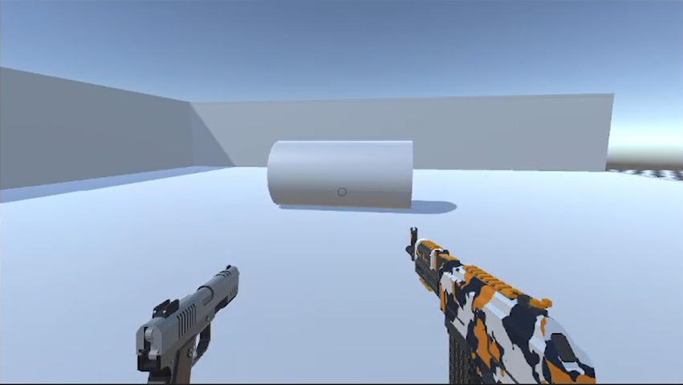**Prototype breakdown**

To the left is a photo of the players pov in the prototype build. This should remain mostly unchanged with the main addition being a HUD.

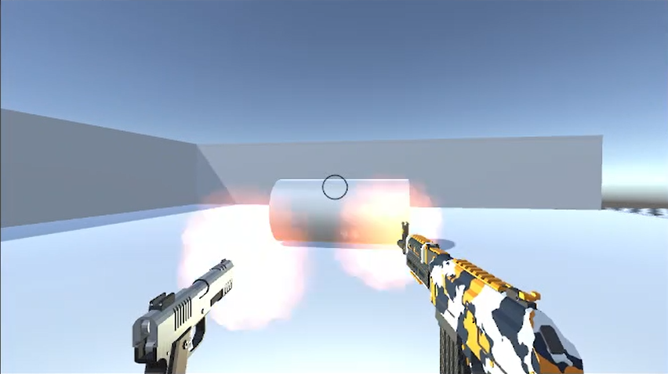Below is a demo of one of the games most important mechanics, shooting.

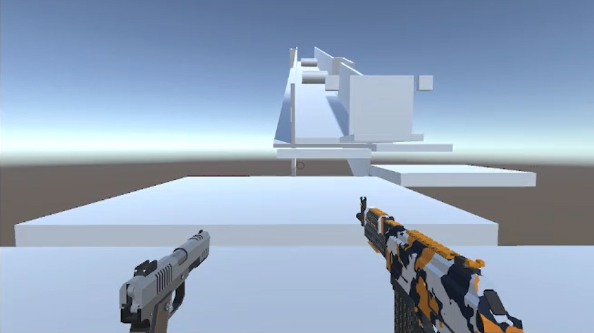To the left is a later stage of the protype build where the player has platforms with gaps that they must jump across too, a obstacle that requires the player to shoot targets to clear and another obstacle that sees deadly barrels rolling down a tight upwards corridor that the player must traverse up.

**External Resources**

# Low Poly Shooter Pack - Free Sample, by Infima Games <https://assetstore.unity.com/packages/templates/systems/low-poly-shooter-pack-free-sample-144839>

This asset package has many resources including scripts that govern player movement, gun firing ,visual effects, lighting and much more. However I only used the models for the handgun and the rifle and the particle system for the muzzle flash. All the code that allow the assets to function in my prototype was written by me, animations created by me and lighting for the muzzle flash created by me. The only thing I got from this package was models, the sound effects and some particle effects.

* Too Many Crosshairs by Clean Shirt Labs <https://assetstore.unity.com/packages/2d/gui/icons/too-many-crosshairs-126069>

This asset package has many crosshairs to choose from. I used one of them and then deleted the asset package from my project since I only needed one individual asset.

* War FX by Jean Moreno

<https://assetstore.unity.com/packages/vfx/particles/war-fx-5669>

The only thing I used from this asset package was the asset for bullet impact on surfaces.